**EYE VERSE**

(EYE DOCTOR’s CLINIC – ONE PAGE WEBSITE)

Done by: Burramukku Anusha

Roll No: 2022MCA16014

Sri Padmavathi mahila visvavidyalayam

Team ID**:** LTVIP2024TMID13900

Team Siz**e:** 1

Team Leader**:** Burramukku Anusha

INDEX

SL.No. Content Page No.

1. INTRODUCTION 3
2. PROBLEM DEFINITION 4

**3. SYSTEM REQUIREMENTS** 5

* 1. Hardware Requirements
  2. Software Requirements
  3. Feasibility Study 9
     1. Operational Feasibility
     2. Technical Feasibility

3.3.3 Economical Feasibility

#### SYSTEM TESTING 10

* 1. Usability testing
  2. Performance Testing

#### SCREEN SHOTS OF WEBSITE 11

1. **CONCLUSION** 19

### INTRODUCTION:

Welcome to Eye Verse, a premier online destination for all things related to eye health and vision care. At Eye Verse, we are dedicated to providing comprehensive information, resources, and support for both patients and eye doctors' clinics alike. Whether you're seeking expert advice on common eye conditions, exploring the latest advancements in vision care technology, or looking for a trusted clinic to address your eye care needs, Eye Verse is here to guide you every step of the way. Our user-friendly platform offers a wealth of informative articles, helpful tips, and convenient tools, including online appointment booking, ensuring that your journey towards optimal eye health is seamless and accessible. Join us in our mission to promote and safeguard the precious gift of sight - together, we envision a brighter, clearer future for all.

### PROBLEM DEFINITION:

Despite the critical importance of eye health and vision care, access to reliable information and services in the field remains fragmented and sometimes inaccessible. Patients often struggle to find comprehensive resources that address their specific concerns, while eye doctors' clinics may face challenges in effectively reaching and engaging with their target audience. Moreover, the rapid advancements in technology and treatments further underscore the need for a centralized platform that bridges the gap between patients and eye care providers. Eye Verse seeks to address these challenges by providing a comprehensive online platform dedicated to eye health, offering curated information, interactive tools, and seamless access to quality care for patients while empowering eye doctors' clinics with enhanced visibility and connectivity within their communities.

### SYSTEM REQUIREMENTS

#### SORTWARE REQUIREMENTS :

#### 1. XAMPP:

#### XAMPP is a free and open-source cross-platform web server solution stack package developed by Apache Friends. The name "XAMPP" is an acronym for "X" (meaning cross-platform), "Apache" (the web server software), "MySQL" (the database management system), "PHP" (the scripting language), and "Perl" (the programming language). XAMPP is designed to simplify the process of setting up a local development environment for web development.

#### Components:

#### - Apache: An open-source web server software that powers a large portion of the internet.

#### - MySQL: An open-source relational database management system used for storing and managing data.

#### - PHP: A server-side scripting language used for developing dynamic web pages and web applications.

#### - phpMyAdmin: A free and open-source web-based administration tool for managing MySQL databases.

#### Purpose:

#### XAMPP provides developers with a pre-configured, easy-to-install package that includes all the necessary components for developing and testing web applications locally. It allows developers to simulate a web server environment on their own computer, enabling them to work on projects offline without the need for internet connectivity or a remote server.

#### Benefits:

#### - Simplifies the setup of a local development environment.

#### - Provides a platform-independent solution (available for Windows, macOS, and Linux).

#### - Includes commonly used web server technologies in a single package.

#### - Facilitates rapid prototyping and testing of web applications.

#### 2. WordPress:

#### Description:

#### WordPress is a free and open-source content management system (CMS) written in PHP and paired with a MySQL or MariaDB database. It is one of the most popular CMS platforms globally, powering millions of websites, including blogs, e-commerce stores, portfolios, and corporate websites. WordPress offers a user-friendly interface and a vast ecosystem of themes, plugins, and extensions, making it highly customizable and suitable for various types of websites.

#### Key Features:

#### - Themes: WordPress offers a wide range of customizable themes that determine the look and feel of a website.

#### - Plugins: Thousands of plugins are available to extend WordPress functionality, adding features such as SEO optimization, e-commerce capabilities, and security enhancements.

#### - Content Management: WordPress provides a user-friendly interface for creating, editing, and organizing website content, including posts, pages, and media.

#### - Community Support: A large and active community of developers and users contribute to the WordPress ecosystem, providing support, documentation, and resources.

#### Purpose:

#### WordPress serves as the backbone of Eye Verse, providing a robust platform for creating and managing the website's content. It enables administrators to publish informative articles, manage appointments, and interact with visitors seamlessly. With its extensive customization options and scalability, WordPress empowers Eye Verse to grow and adapt to evolving needs.

#### : Benefits

#### - User-friendly interface: Easy to use, even for non-technical users.

#### - Customization: Highly customizable with themes and plugins to suit specific requirements.

#### - SEO-friendly: Built-in features and plugins support search engine optimization.

#### - Scalability: Can accommodate websites of all sizes, from small blogs to large enterprise platforms.

#### - Community support: Access to a vast community of users and developers for assistance and resources.

#### By leveraging XAMPP and WordPress, Eye Verse can establish a robust and flexible web presence tailored to the needs of eye doctors' clinics and their patients. XAMPP provides the necessary server environment, while WordPress offers a versatile CMS platform for content creation and management. Together, they form the foundation for an effective and user-friendly website solution.

#### HARDWARE REQUIREMENT:

#### 3.2.1 SOFTWARE REQUIREMENT:

The hardware requirements for hosting a website like Eye Verse, powered by XAMPP and WordPress, typically depend on factors such as expected traffic, database size, and specific functionalities. Here's a general outline of hardware requirements:

**Processor (CPU):**

A multi-core processor, such as an Intel Core i5 or AMD Ryzen 5, is recommended for optimal performance.

Higher clock speeds and more cores can handle concurrent requests and database operations more efficiently.

**Memory (RAM):**

A minimum of 8 GB of RAM is recommended for hosting WordPress websites.

More RAM may be necessary for handling larger databases, caching, and managing concurrent user sessions.

For larger websites with heavy traffic, consider upgrading to 16 GB or more for better performance.

**Storage (Hard Drive or SSD):**

A solid-state drive (SSD) is preferable over a traditional hard disk drive (HDD) for faster read/write speeds and improved overall performance.

A minimum of 50 GB of storage space is recommended for hosting the operating system, web server software, WordPress files, and database.

Additional storage may be required for backups, media files (images, videos), and log files.

**Network Interface:**

A stable internet connection with sufficient bandwidth is essential for serving web pages, handling user requests, and transferring data.

Consider a broadband connection with upload and download speeds suitable for the expected website traffic.

**Optional Hardware:**

Graphics Processing Unit (GPU): Generally not required for hosting a website, but GPU acceleration can be beneficial for certain tasks such as image processing or video encoding.

Redundant Power Supply (UPS): Provides backup power in case of outages, ensuring continuous operation and data integrity.

Cloud **hosting** providers such as Amazon Web Services (AWS), Google Cloud Platform (GCP), or Microsoft Azure offer scalable infrastructure options tailored to web hosting needs.

**Operating System:**

XAMPP and WordPress are compatible with Windows, macOS, and Linux operating systems.

Choose an operating system based on familiarity, performance, and support requirements.

These hardware requirements serve as a guideline for setting up a reliable and performant hosting environment for Eye Verse. Depending on the specific needs and anticipated growth of the website, adjustments may be necessary to ensure optimal performance and user experience.

### FEASIBILITY STUDY:

#### OPERATIONAL FEASIBILITY:

The operational feasibility of Eye Verse, powered by XAMPP and WordPress, is highly promising. Both XAMPP and WordPress are widely adopted, user-friendly platforms with extensive documentation and support communities, ensuring ease of implementation and maintenance. The technical requirements for hosting Eye Verse are well-defined and can be met with readily available hardware and software components. Additionally, the affordability and accessibility of the necessary resources, including servers, domain names, and internet connectivity, further enhance the feasibility of the project. Integration with existing systems within eye doctors' clinics and external services is seamless, thanks to the customization options and integration capabilities offered by XAMPP and WordPress. With its intuitive interfaces and straightforward workflows, Eye Verse is poised to be embraced by users, requiring minimal training for effective utilization.

#### TECHNICAL FEASIBILITY:

XAMPP provides a comprehensive and easily deployable web server environment, including Apache, MySQL, PHP, and phpMyAdmin, facilitating the setup of a local development environment for WordPress. WordPress, as a popular content management system, offers a user-friendly interface and extensive customization options through themes and plugins. The compatibility of XAMPP and WordPress across multiple operating systems ensures flexibility in deployment, while their extensive documentation and online support communities provide resources for troubleshooting and guidance. With well-defined technical requirements and straightforward implementation processes, Eye Verse is technically feasible for eye doctors' clinics looking to establish an online presence effectively.

#### ECONOMICAL FEASIBILITY:

Both XAMPP and WordPress are open-source platforms, eliminating the need for expensive software licenses. Additionally, the hardware requirements for hosting Eye Verse, such as servers and storage, are affordable and readily available. With the option to choose from a range of hosting providers offering competitive pricing plans, eye doctors' clinics can find a solution that aligns with their budgetary constraints. Moreover, the scalability of XAMPP and WordPress allows Eye Verse to grow alongside the clinics' needs without significant additional costs. Furthermore, by establishing an online presence through Eye Verse, clinics can potentially reduce overhead costs associated with traditional marketing methods while reaching a broader audience. Overall, the economic feasibility of Eye Verse is promising, offering a cost-effective solution for clinics seeking to enhance their online visibility and patient engagement.

### SYSTEM TESTING:

#### USABILITY TESTING:

Usability testing for the Eye Verse website involves evaluating its interface, functionality, and user experience. Test participants, including eye doctors, clinic staff, and patients, perform tasks such as scheduling appointments and exploring services. Observations and feedback help identify usability issues and inform iterative improvements. The goal is to ensure an intuitive and efficient website that meets the needs of all users.

Iterative testing is conducted as needed, especially after implementing significant changes or updates to the Eye Verse website. This allows us to continuously gather feedback from users and ensure ongoing improvements to the website's usability and user experience.

Ultimately, the goal of usability testing is to create a website that effectively serves the needs of eye doctors' clinics and their patients by providing an intuitive, efficient, and enjoyable online experience. Through thorough testing and iterative refinement, we aim to achieve this goal and deliver a website that exceeds user expectations.

#### PERFORMANCE TESTING:

Performance testing for Eye Verse is essential to ensure that the website operates smoothly and efficiently under varying conditions, providing a seamless user experience for eye doctors' clinics and their patients. This type of testing involves evaluating the responsiveness, speed, and stability of the website, particularly during peak usage periods or when subjected to high levels of traffic.

To conduct performance testing, simulation of real-world scenarios where multiple users access the website simultaneously, perform actions such as browsing services, scheduling appointments, and accessing educational resources. Through load testing, we measure how the website responds to increased levels of traffic and user interactions, identifying any bottlenecks or performance issues that may arise. Stress testing helps us determine the website's stability and scalability by pushing it beyond its normal operating capacity to assess its ability to handle extreme levels of traffic or sudden spikes in usage. By conducting thorough performance testing, we can proactively identify and address any performance-related issues, optimize website performance, and ensure that Eye Verse delivers a fast, reliable, and responsive user experience for all users.

**5, SCREEN SHOTS OF WEBSITE**

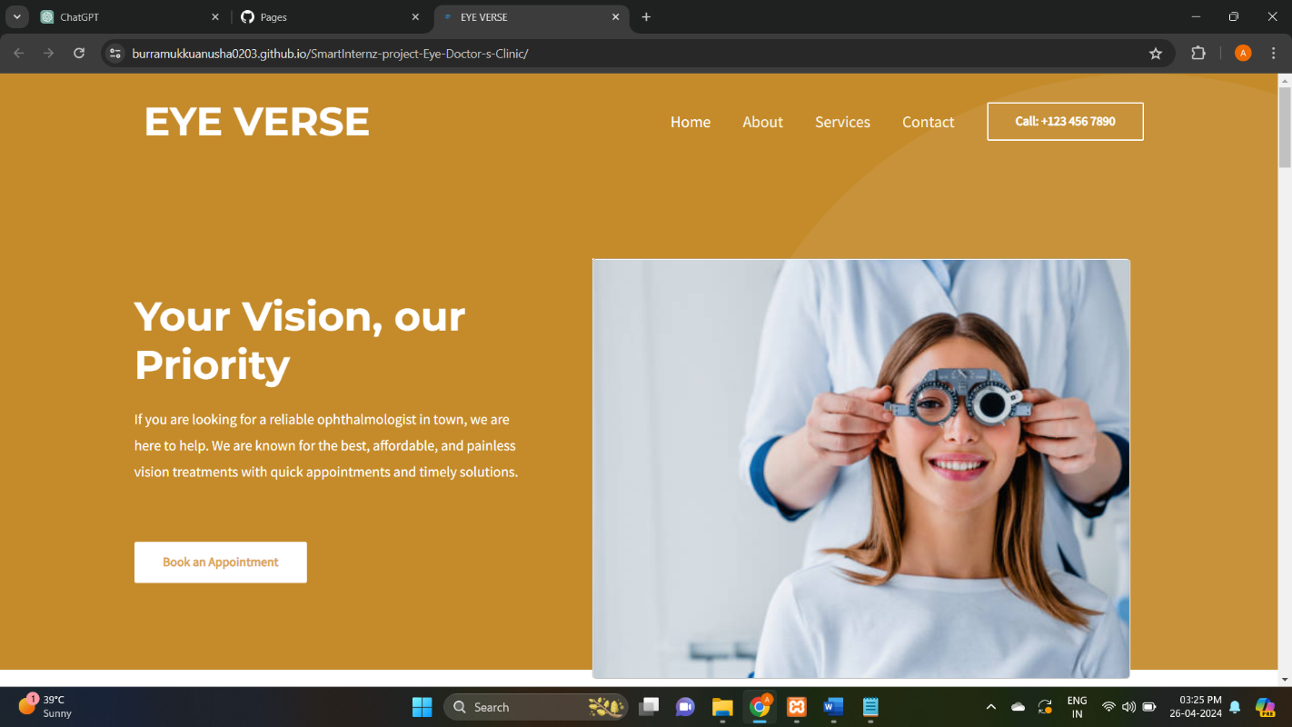

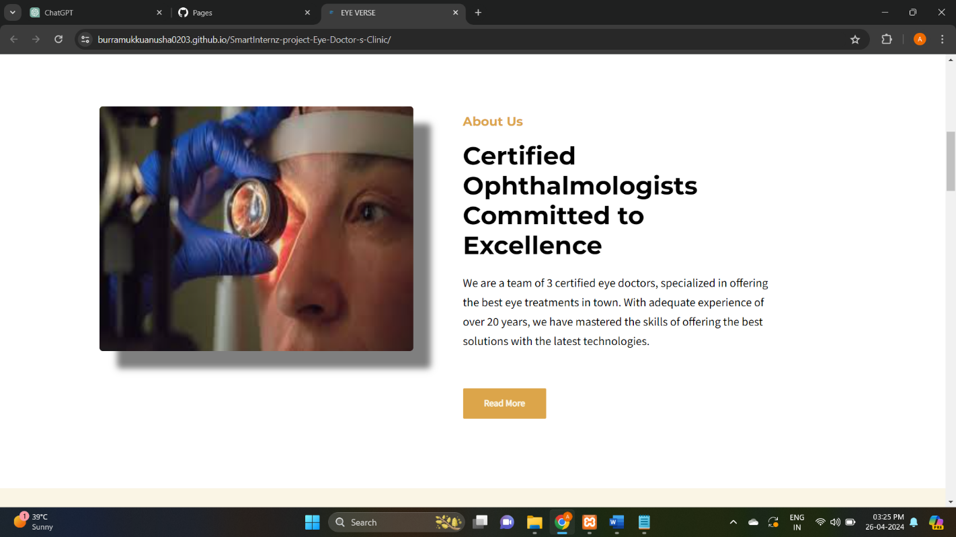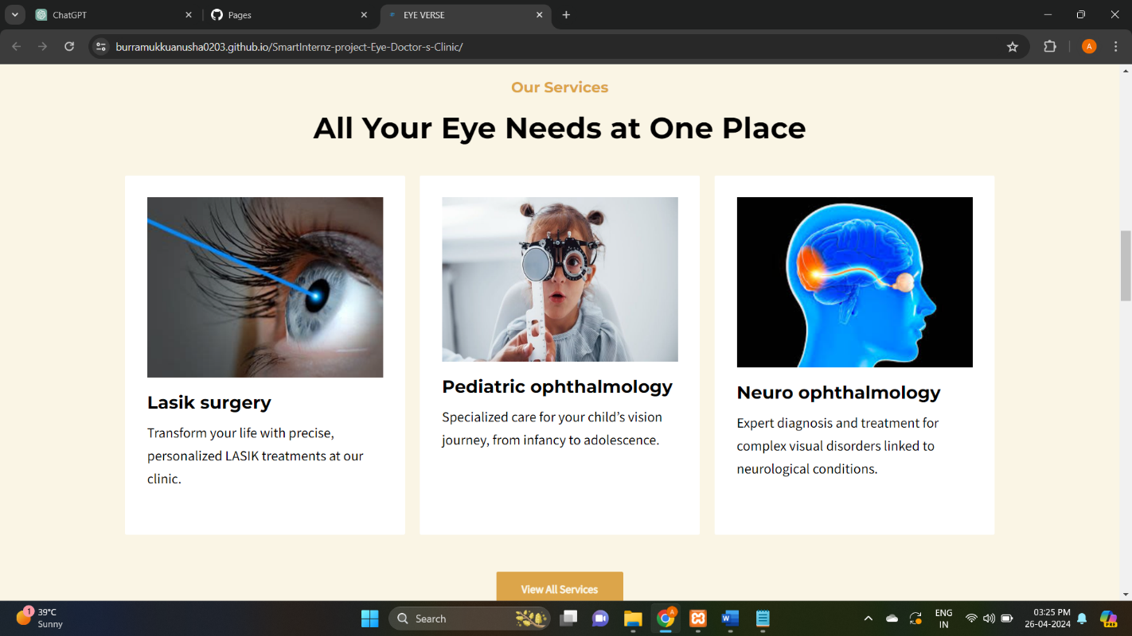

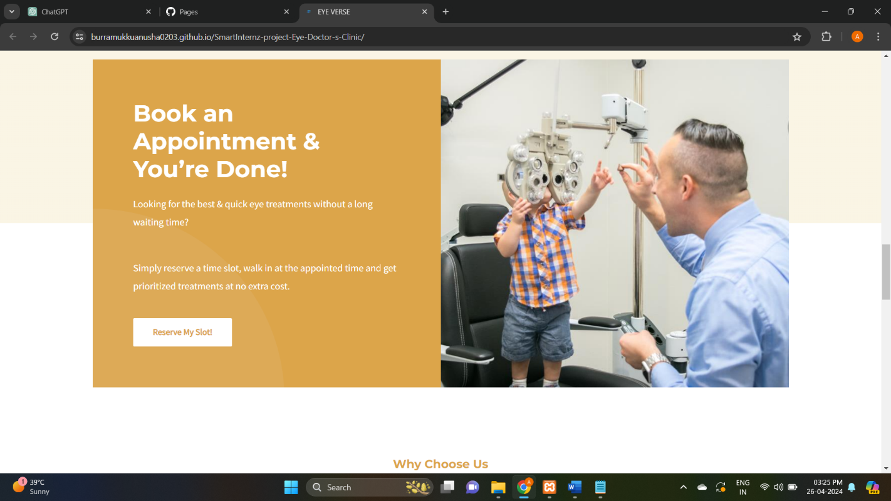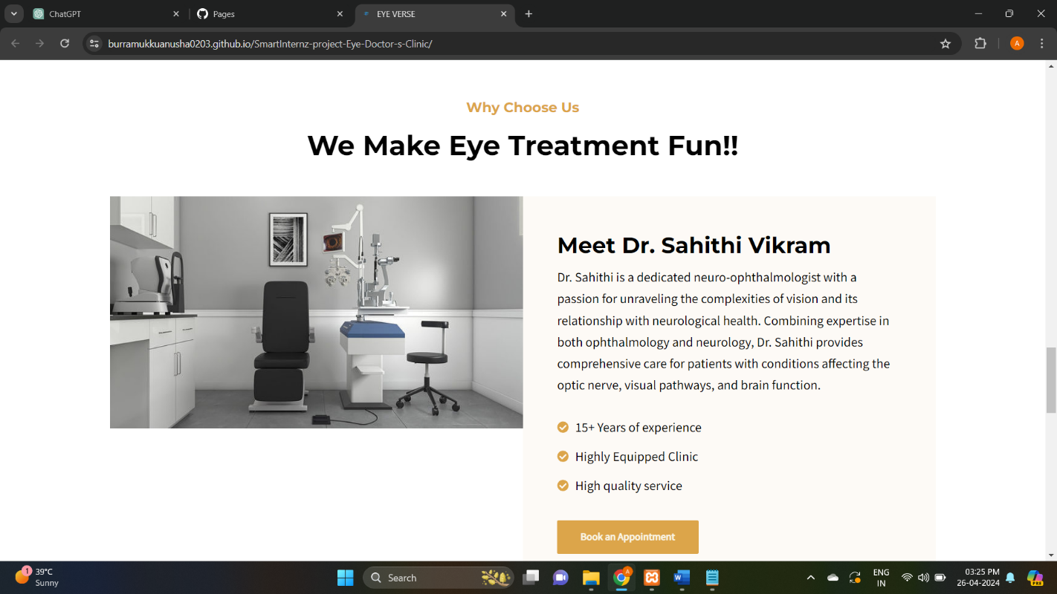

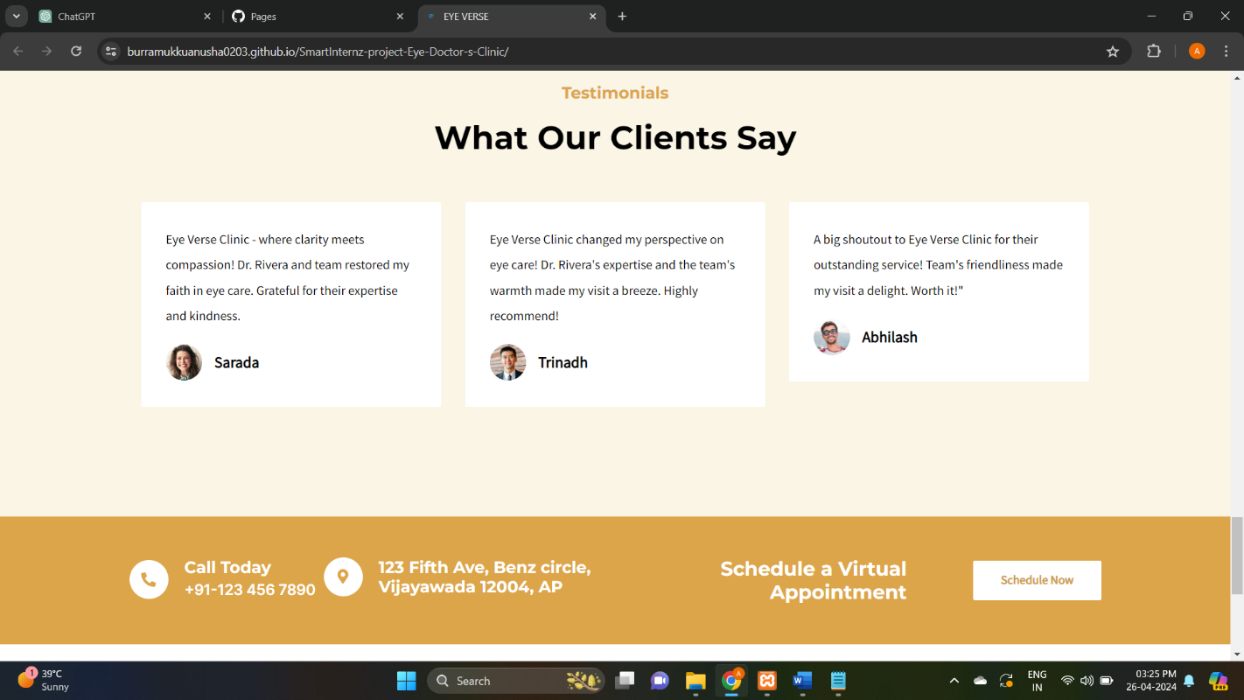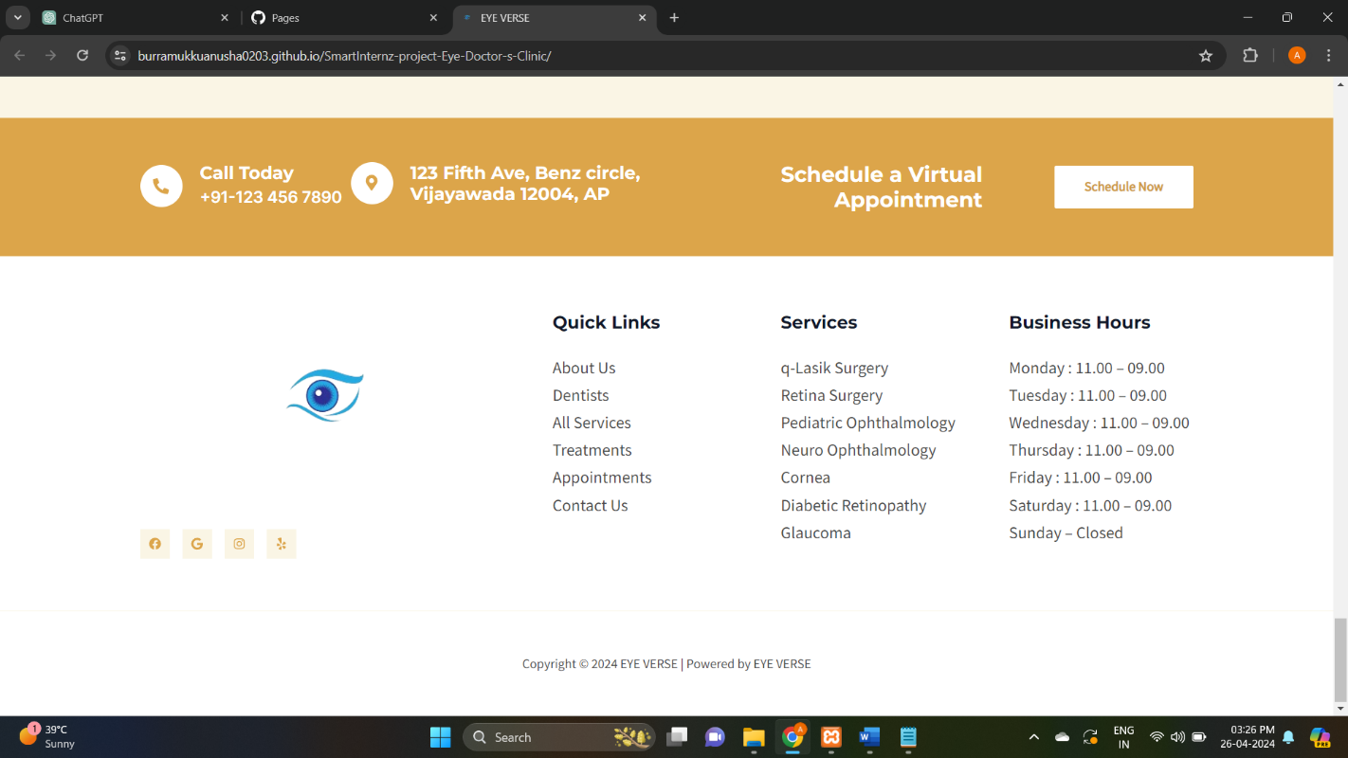

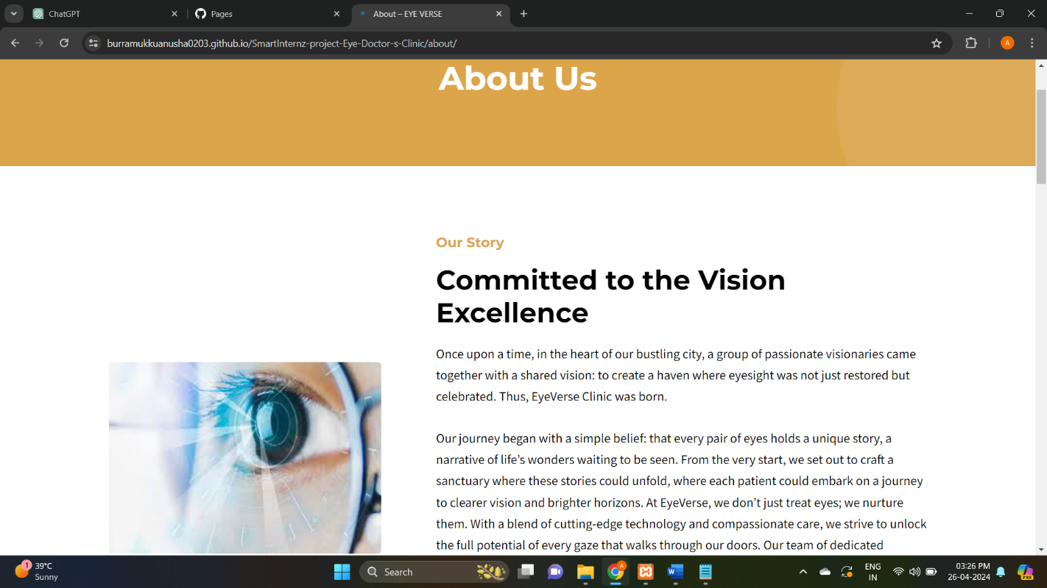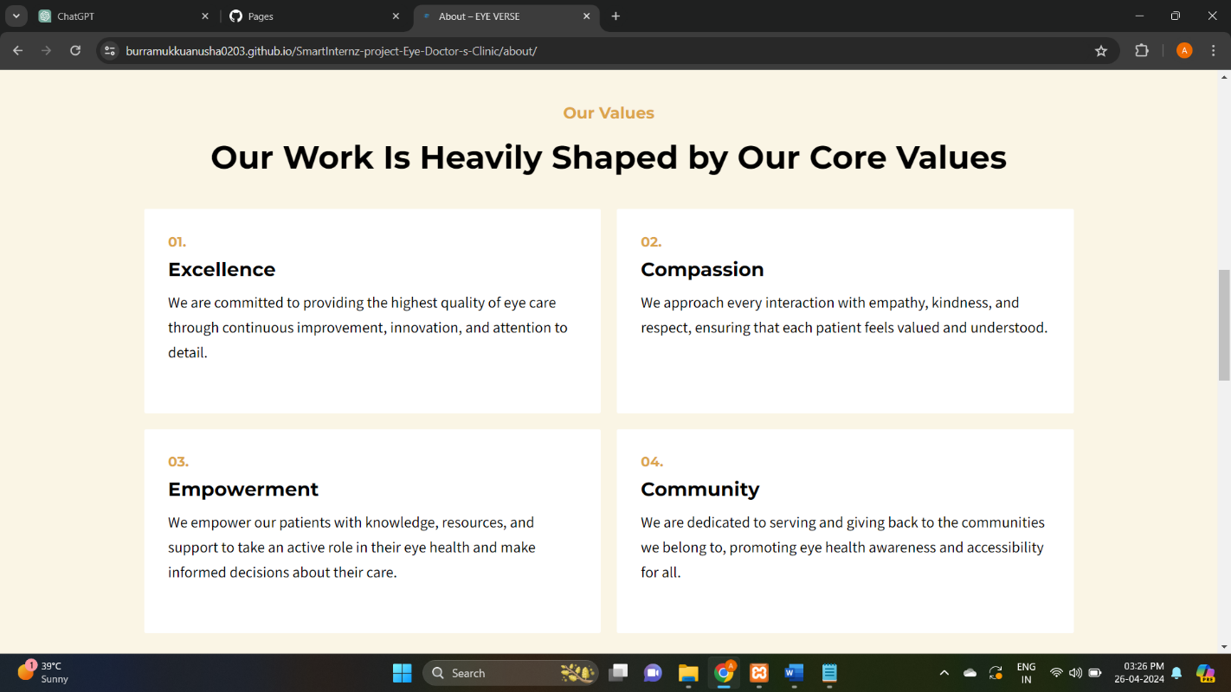

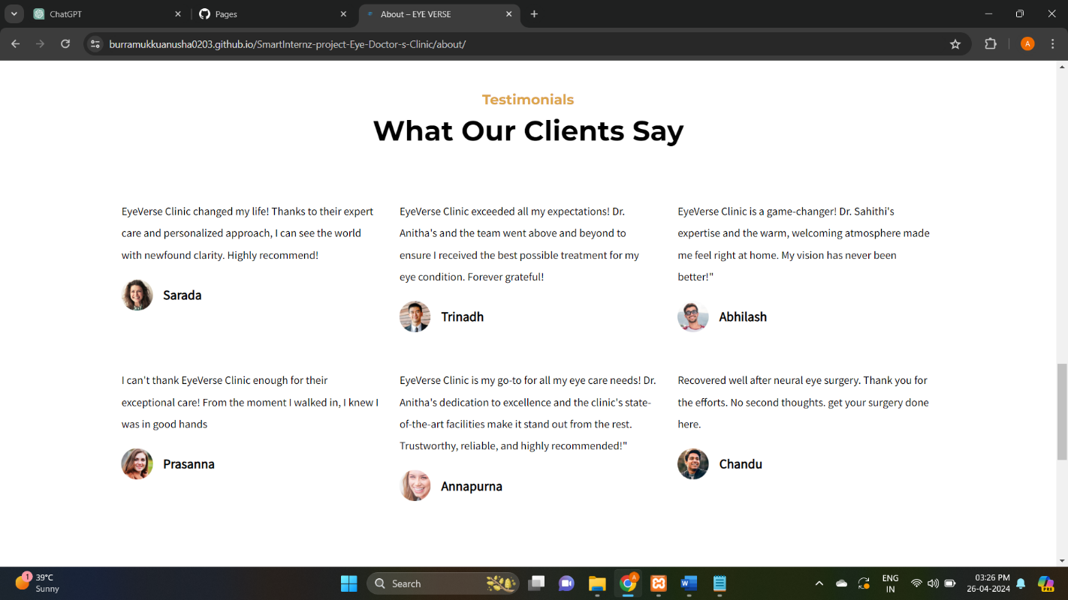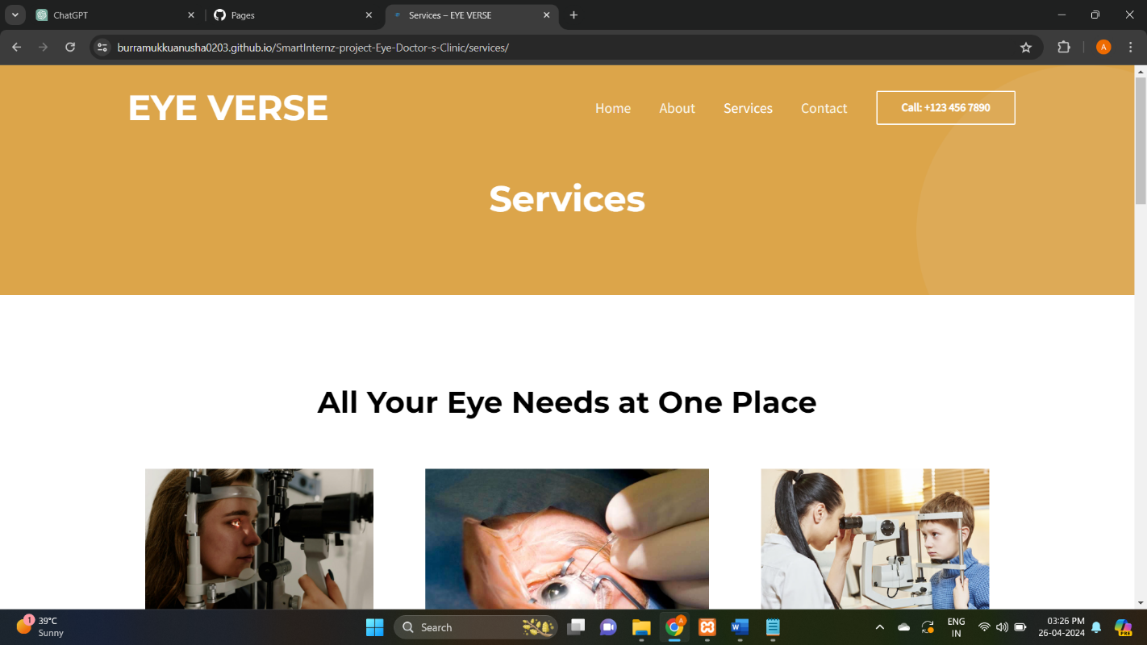

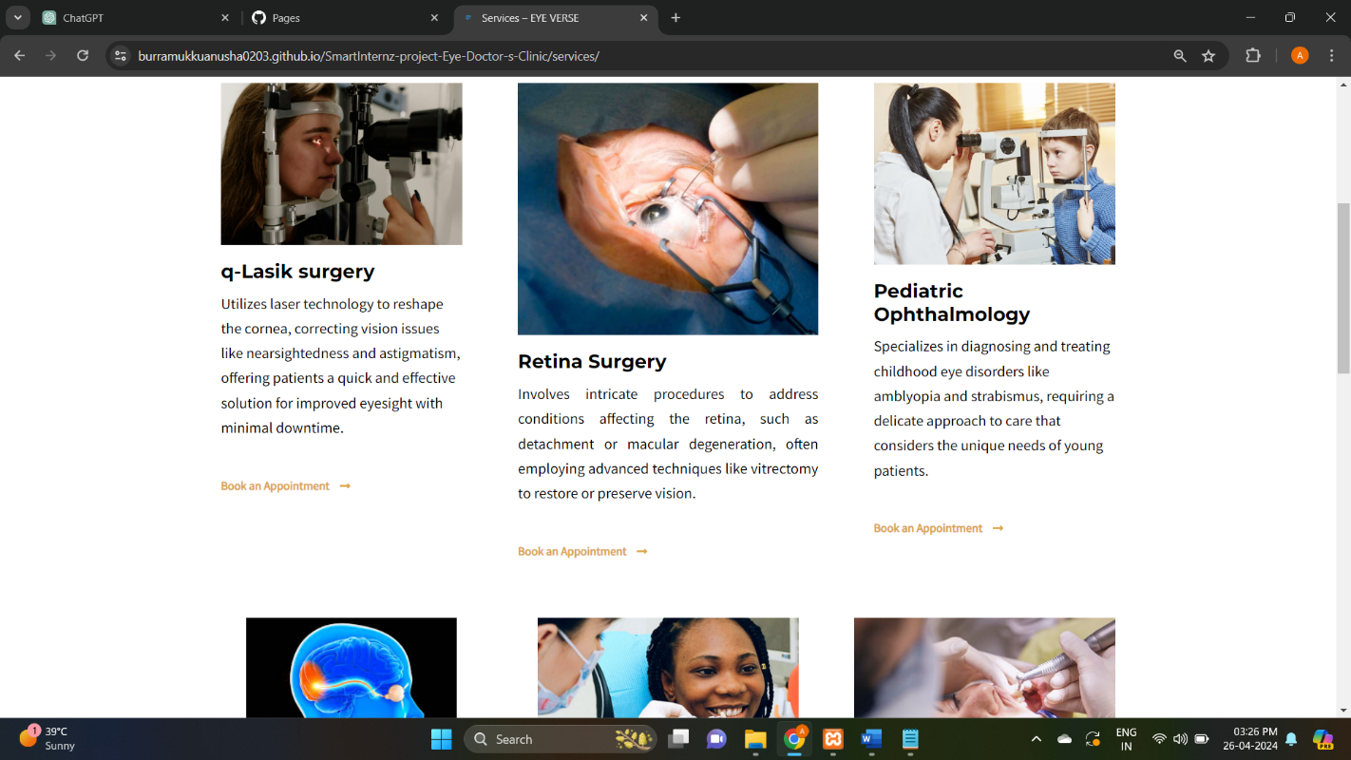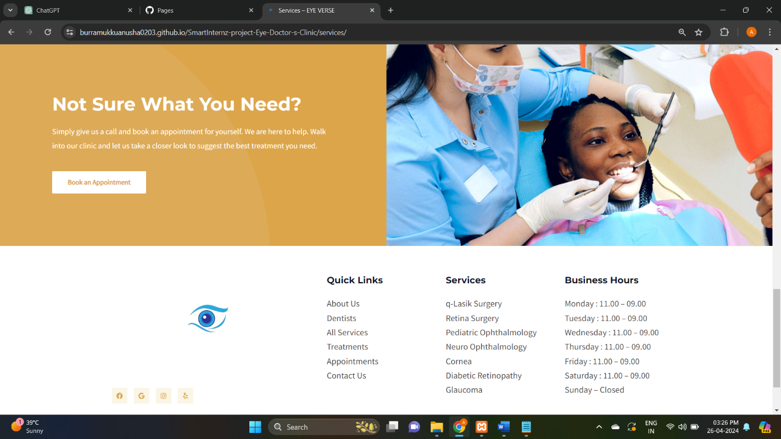

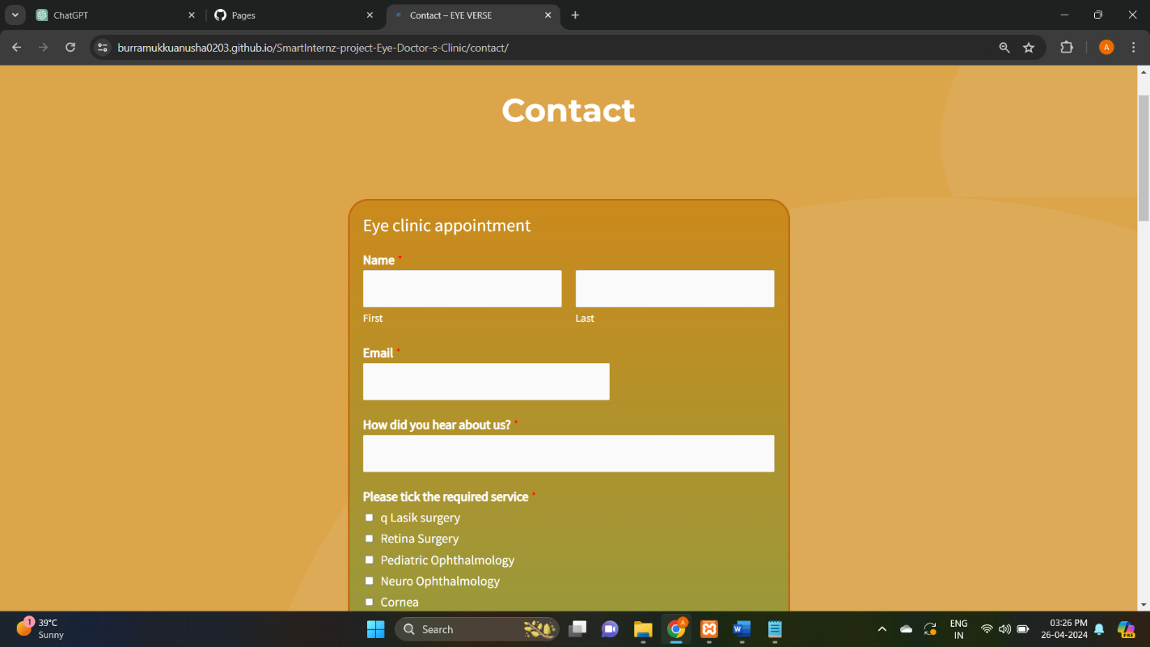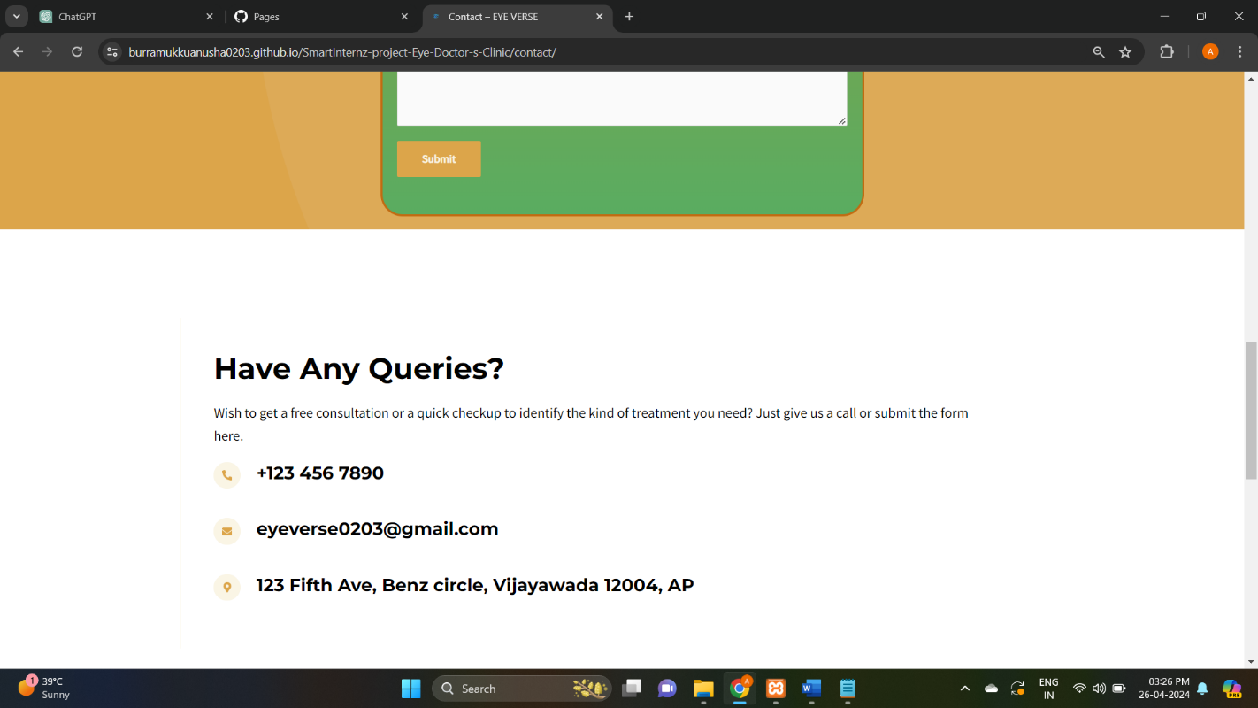

1. **CONCLUSION**

In conclusion, conducting usability and performance testing for Eye Verse is crucial for ensuring that the website meets the needs and expectations of both eye doctors' clinics and their patients. Through usability testing, we gather valuable feedback from representative users, allowing us to identify usability issues, improve navigation, and enhance overall user experience. Additionally, performance testing helps us evaluate the website's responsiveness, speed, and stability under various conditions, ensuring that it can handle high levels of traffic and provide a seamless browsing experience for all users. By prioritizing usability and performance testing, we can optimize the design and functionality of Eye Verse, delivering a user-friendly and reliable online platform that effectively serves the needs of eye doctors' clinics and their patients.

Website Link: [burramukkuanusha0203.github.io/SmartInternz-project-Eye-Doctor-s-Clinic/](https://burramukkuanusha0203.github.io/SmartInternz-project-Eye-Doctor-s-Clinic/)